**Forever 21: Rags to Riches!**

Success doesn't always come to your door knocking around and opening the ways for you, various risks and efforts are required to get a successful ending and achieve something good.

Forever 21, how did it all started? What is the story behind the founders of Forever 21? How easy it is to get a successful brand and how easy was it for the owners of Forever 21?

A South Korean husband-wife duo launched Forever 21 in the year 1984, in Los Angeles. From working at gas stations to now being the owner of a fashion giant, Forever 21’s owners Jin Sook and Do Won Chang have been able to transform their lives from rags to riches.



**Starting of the harsh journey in California:**

When the duo entered California, they were penniless, didn't have any fluency in English, and had no college degrees. Can you imagine how difficult it is to survive with such issues?

The journey was not at all easy and Do Won had to work as a janitor then for gas pumping and then several coffee shops to survive and these all continued for about three years after their entry in California.

Do Won stated in his interview with Forbes how survival was very difficult in South Korea during those times and opportunities were very narrow that was the reason for their shifting!

Without wasting even a single day, Do Won just started surfing through various classified sections for jobs and landed on various interviews, and soon after that, he was there washing dishes and preparing meals in the coffee shops with a minimum wage of around $3 per hour. To you have a good survival he started with eight more hours working at a gas station and then office cleaning business which altogether kept him busy until midnight.

Jin Sook started working as a hairdresser and contributed to income and survival.

During his work hours in the gas station, Do Won noticed that the owners and founders of garment Industries drove the nicest cars and had an Elite class living. And, this inspired him to take a job at a clothing store to start with the staircase of success. His dedication towards the job in the garment sector impressed his boss a lot!

**Fashion 21 to Forever 21:**

Three years after that in 1984, the couple managed to transfer about $11,000 in Savings, and with this, they started a 900 square foot store known as Fashion 21.

Yes, Forever 21 earlier was Fashion 21!

Fashion 21 managed to make $700,000 in just the first year with wholesale close-outs and acquiring merchandise directly from the manufacturers at discounts. The success was so enormous that every six months there was a new opening for the fashion brand and it was soon named Forever 21.

During the great recession in 2008, they aimed to open more stores and create about 7,000 jobs within a year and his plans were not only for about sales and profits but also to increase the job opportunities for people. Around 480 stores all across the world were started soon that generated about 3 billion dollars every year.

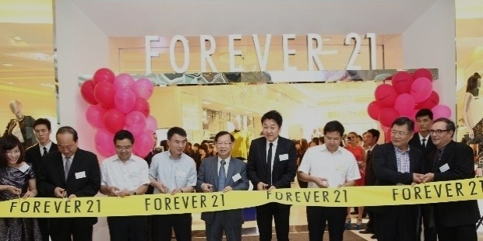

**The Downfall!**

However, ups and downs are a part of living, and just like how successful Forever 21 became, from 2019 there has been a downfall in the company!

Surprisingly, just how penniless became billionaires, sudden downfall made them bankrupt too!

With Jin Sook approving about 400 designs every day, they aimed to open 600 new stores in three years from 2017. However, this aggression in expanding the lead to their design being more common and they lacked to cope up with the changes in the consumer requirements. People prefer online buying and less-expensive products that Forever 21 didn’t pace up with.

They were reported to pay late to some vendors and the delivery company scrap the contracts to cover 171 stores, and this dropped the business by 50% by the last year.

Losing the competition with H&M and Zara, soon in no time Forever 21 became a wide joke with getting $500 million of debt and planning to file for bankruptcy. With this, the company plans to close the less profitable stores in Europe and Asia, and continue with the profitable ones in Mexico, Latin America, and no exit planned from the US markets.

As the negotiations continue, the number of stores to be closed is still hidden. They aim to maintain their position in the US, however, to get back their buyers and success back!

